NAME:

The Americas

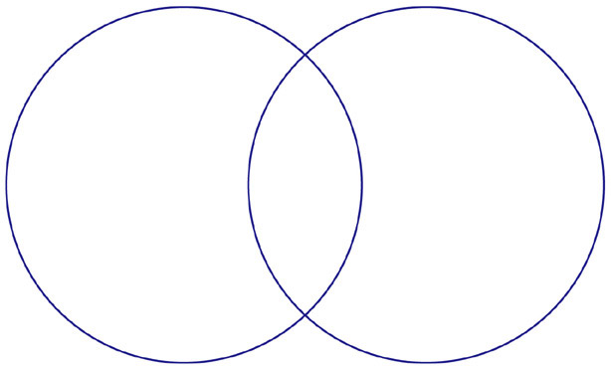
Mexica
Incas

